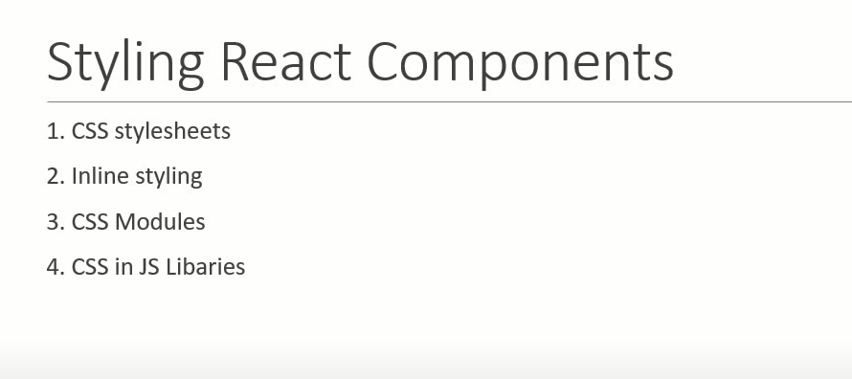

1. Stylesheet Css :

Css File :

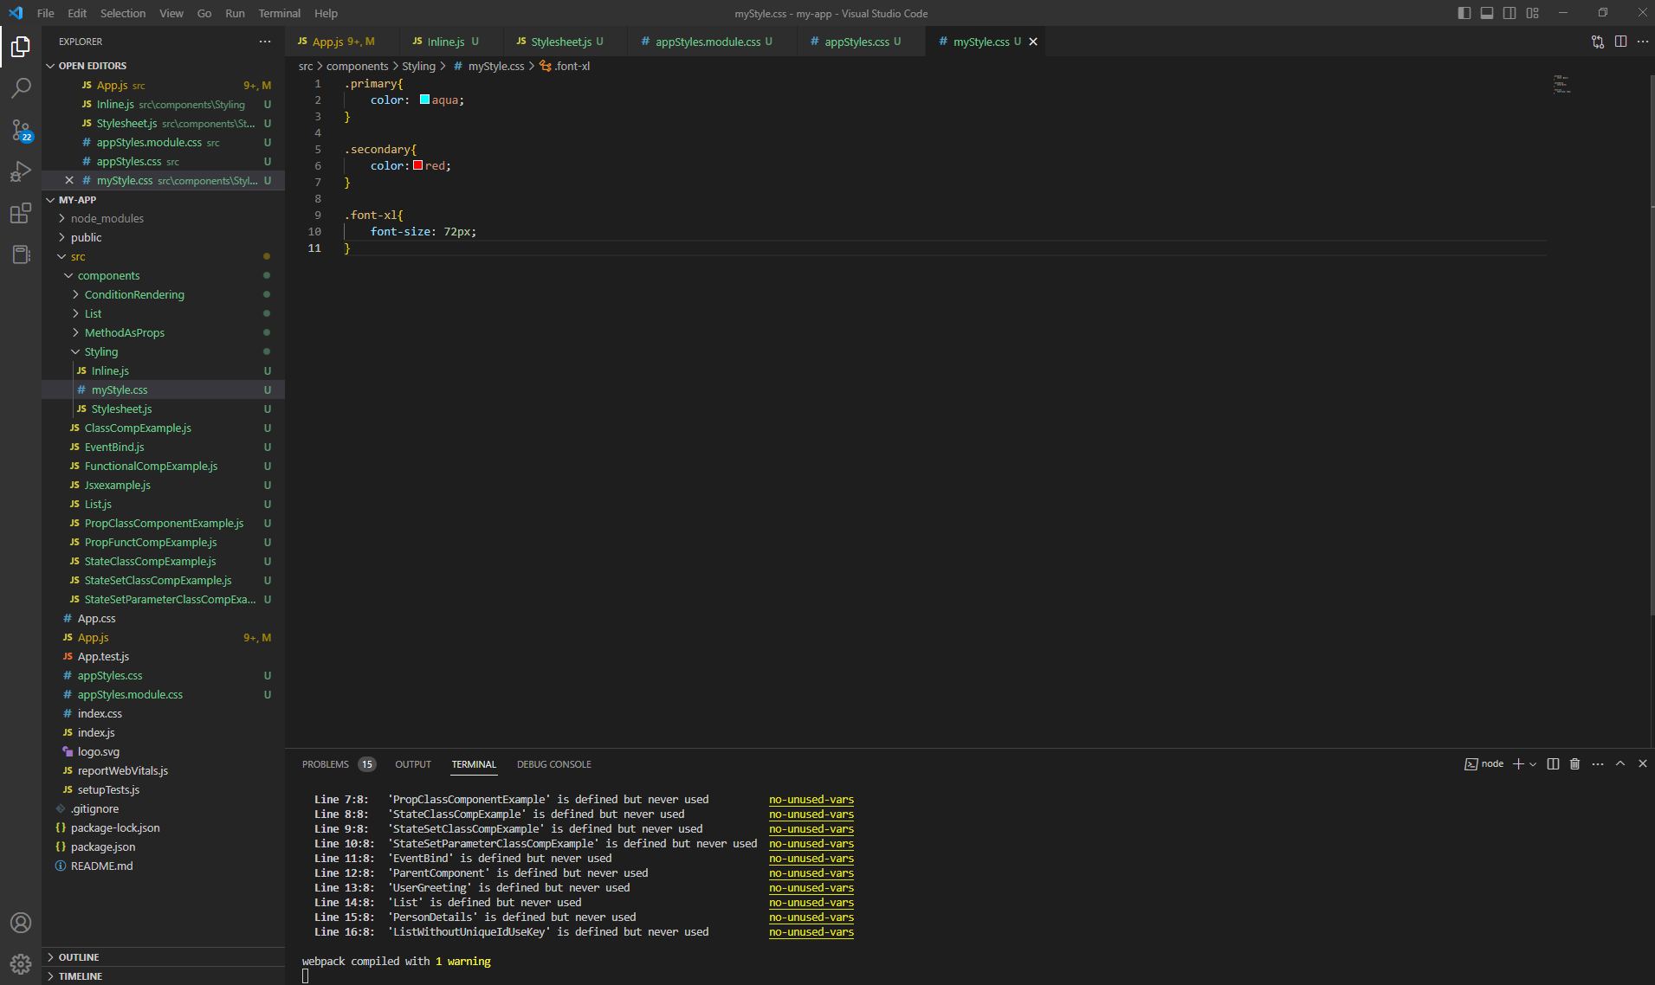

.primary{

    color: aqua;

}

.secondary{

    color:red;

}

.font-xl{

    font-size: 72px;

}

Js File :

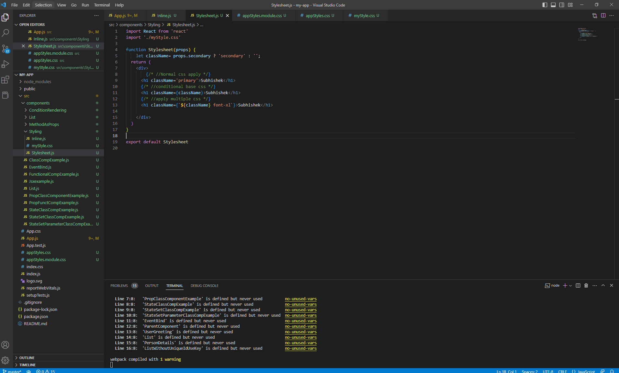

import React from 'react'

import './myStyle.css'

function Stylesheet(props) {

    let className= props.secondary ? 'secondary' : '';

  return (

    <div>

        {/\* //Normal css apply \*/}

      <h1 className='primary'>Subhishek</h1>

      {/\* //conditional base css \*/}

      <h1 className={className}>Subhishek</h1>

      {/\* //apply multiple css \*/}

      <h1 className={`${className} font-xl`}>Subhishek</h1>

    </div>

  )

}

export default Stylesheet

pass condition based add css

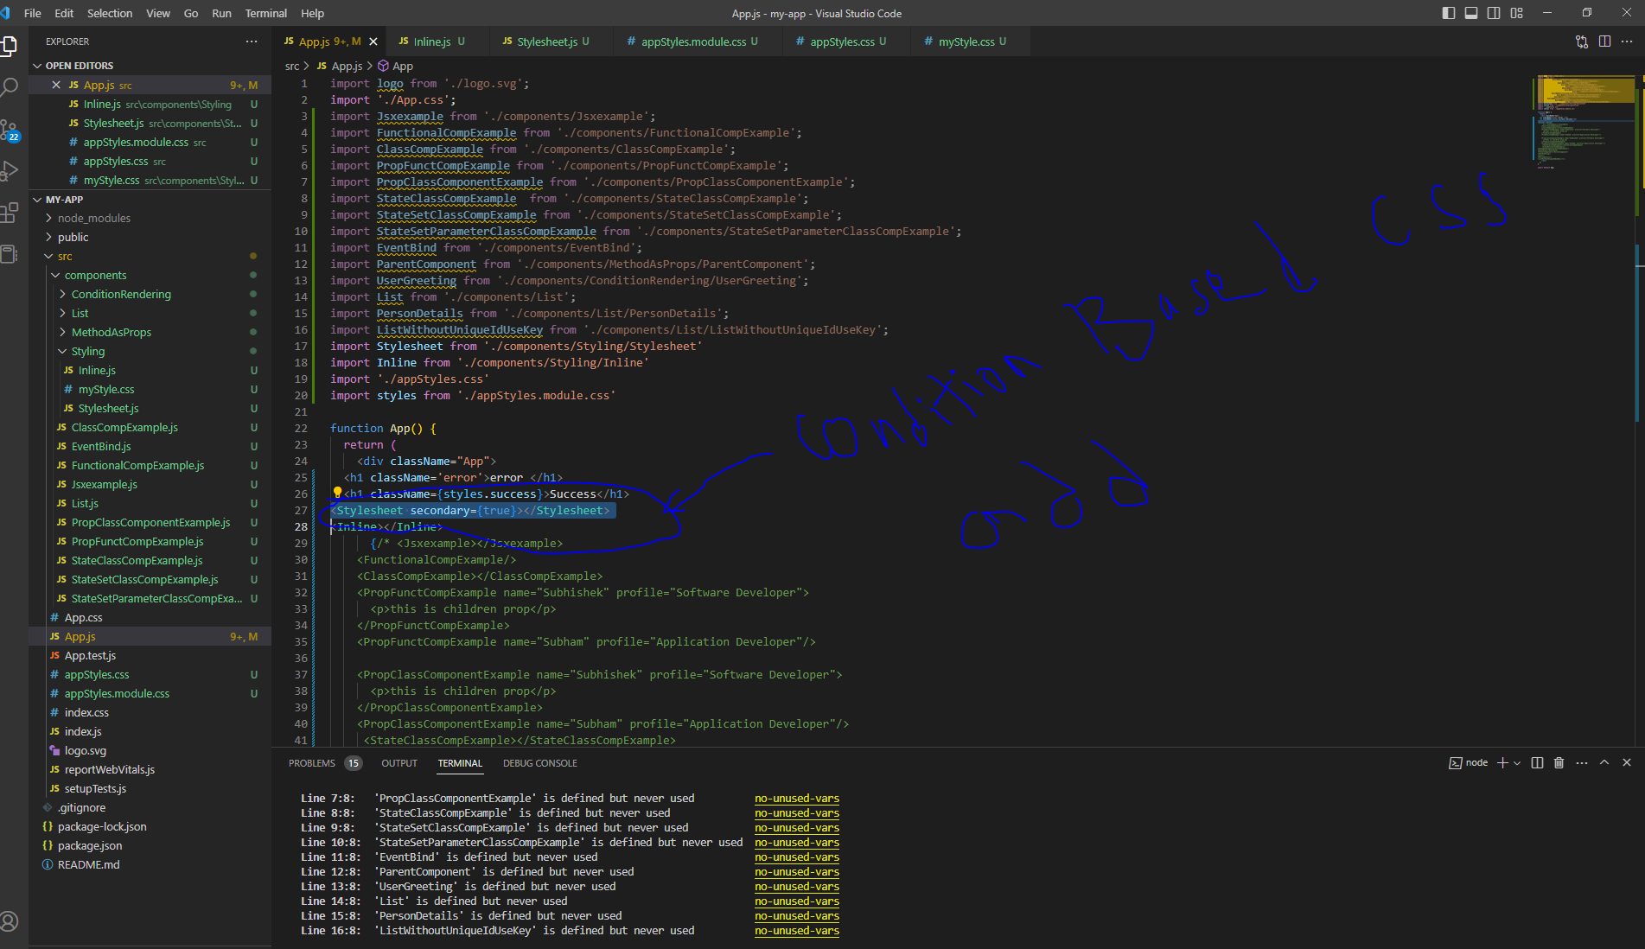

1. Inline Css :

import React from 'react'

const heading= {

    fontSize:'72px',

    color:'blue'

}

function Inline() {

  return (

    <div>

      <h3 style={heading}>Inline</h3>

    </div>

  )

}

export default Inline

1. Css Module :

Create css file “.module.css” must

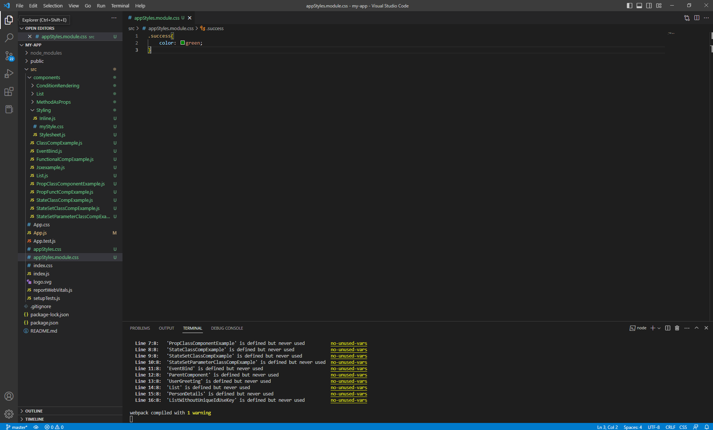

Then import and use object

